Buffer Manager

🧠 What Is a Buffer Manager in a DBMS?
# Source: AI Source: Provided by: [Data Path: Persons Table -> ID Column: 1, Name_En Column: Motasem Essam] -> From: [ChatGPT] on [6/10/2026]
The Buffer Manager is the component of a Database Management System (DBMS) that manages a portion of RAM (called the buffer pool) used to temporarily hold database pages that are read from or written to disk.
Its goal is to reduce disk I/O and speed up query performance by keeping frequently used data in memory.

🧩 Why Is It Needed?
# Source: AI Source: Provided by: [Data Path: Persons Table -> ID Column: 1, Name_En Column: Motasem Essam] -> From: [ChatGPT] on [6/10/2026]
Accessing data from RAM (memory) is thousands of times faster than from disk (HDD or SSD).
So instead of reading from disk every time, the Buffer Manager:
- Loads data pages into memory when needed
- Keeps them in memory while they’re being used
- Evicts old or less-used pages to make space
- Writes modified pages (dirty pages) back to disk

🔍 Responsibilities of the Buffer Manager
# Source: AI Source: Provided by: [Data Path: Persons Table -> ID Column: 1, Name_En Column: Motasem Essam] -> From: [ChatGPT] on [6/10/2026]
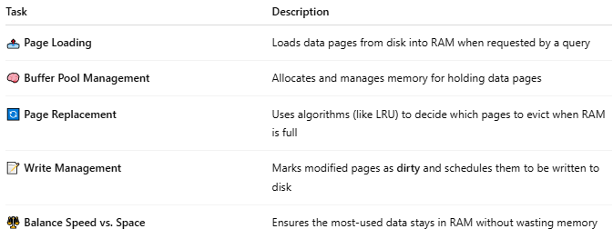
Task | Description
📤 Page Loading | Loads data pages from disk into RAM when requested by a query
🧠 Buffer Pool Management | Allocates and manages memory for holding data pages
🔄 Page Replacement | Uses algorithms (like LRU) to decide which pages to evict when RAM is full
📝 Write Management | Marks modified pages as dirty and schedules them to be written to disk
⚖️ Balance Speed vs. Space | Ensures the most-used data stays in RAM without wasting memory

🗂️ How It Works (Simplified)
# Source: AI Source: Provided by: [Data Path: Persons Table -> ID Column: 1, Name_En Column: Motasem Essam] -> From: [ChatGPT] on [6/10/2026]
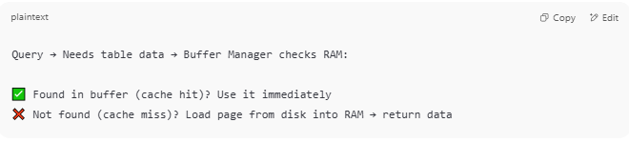
Query → Needs table data → Buffer Manager checks RAM:

✅ Found in buffer (cache hit)? Use it immediately
❌ Not found (cache miss)? Load page from disk into RAM → return data

⚙️ Key Concepts
# Source: AI Source: Provided by: [Data Path: Persons Table -> ID Column: 1, Name_En Column: Motasem Essam] -> From: [ChatGPT] on [6/10/2026]
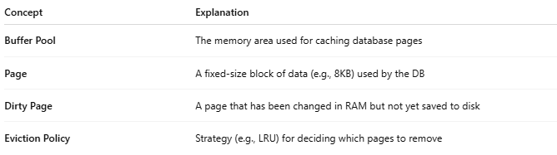
Concept | Explanation
Buffer Pool | The memory area used for caching database pages
Page | A fixed-size block of data (e.g., 8KB) used by the DB
Dirty Page | A page that has been changed in RAM but not yet saved to disk
Eviction Policy | Strategy (e.g., LRU) for deciding which pages to remove

📈 Performance Benefits
# Source: AI Source: Provided by: [Data Path: Persons Table -> ID Column: 1, Name_En Column: Motasem Essam] -> From: [ChatGPT] on [6/10/2026]
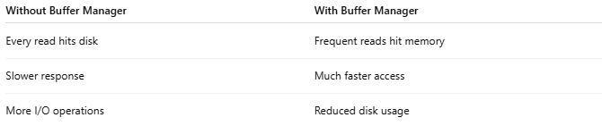
Without Buffer Manager | With Buffer Manager
Every read hits disk | Frequent reads hit memory
Slower response | Much faster access
More I/O operations | Reduced disk usage

🛠️ In Popular DBMSs
# Source: AI Source: Provided by: [Data Path: Persons Table -> ID Column: 1, Name_En Column: Motasem Essam] -> From: [ChatGPT] on [6/10/2026]
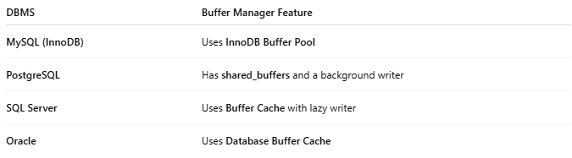
DBMS | Buffer Manager Feature
MySQL (InnoDB) | Uses InnoDB Buffer Pool
PostgreSQL | Has shared_buffers and a background writer
SQL Server | Uses Buffer Cache with lazy writer
Oracle | Uses Database Buffer Cache

🧪 Analogy
# Source: AI Source: Provided by: [Data Path: Persons Table -> ID Column: 1, Name_En Column: Motasem Essam] -> From: [ChatGPT] on [6/10/2026]
The Buffer Manager is like a library desk:
- Keeps the most requested books (data) ready on the desk (RAM)
- Fetches from the storage room (disk) only when needed
- Puts away old books when space runs out

📌 Summary
# Source: AI Source: Provided by: [Data Path: Persons Table -> ID Column: 1, Name_En Column: Motasem Essam] -> From: [ChatGPT] on [6/10/2026]
The Buffer Manager keeps hot (frequently used) data in RAM to avoid slow disk reads, improving query speed and overall database performance. It plays a vital role in caching and I/O efficiency.

